1. **TOY PROBLEM: (TOWER OF HANOI):**

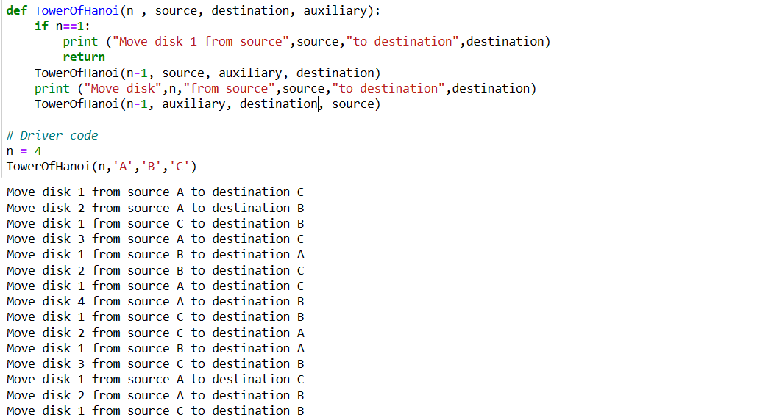

1. **REAL WORLD AGENT PROBLEM**

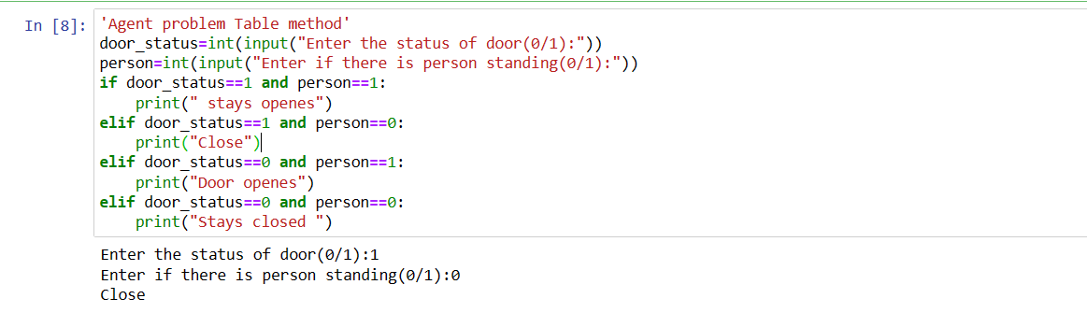

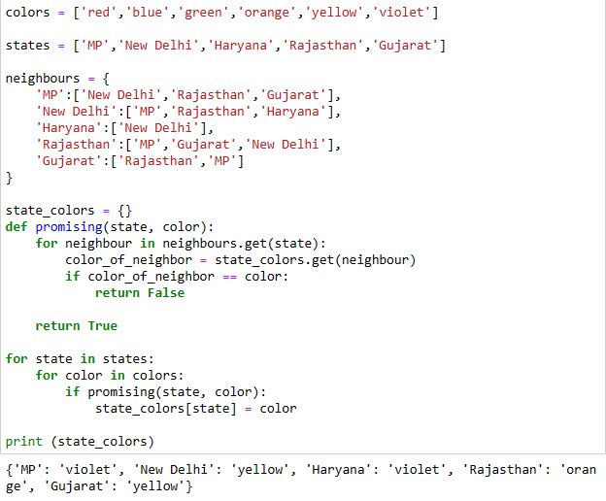

1. **CONSTRAINT SATISFACTION PROBLEM:**

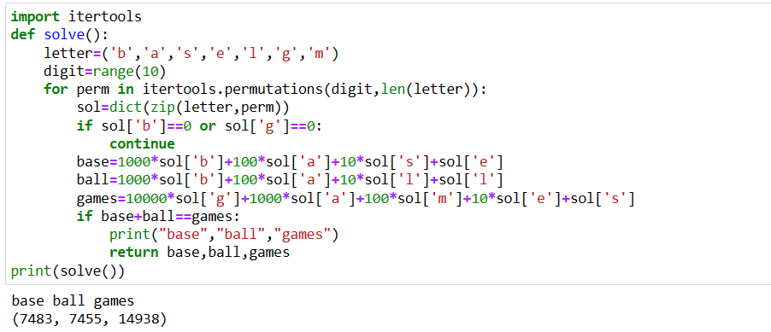

1. **DFS AND BFS**

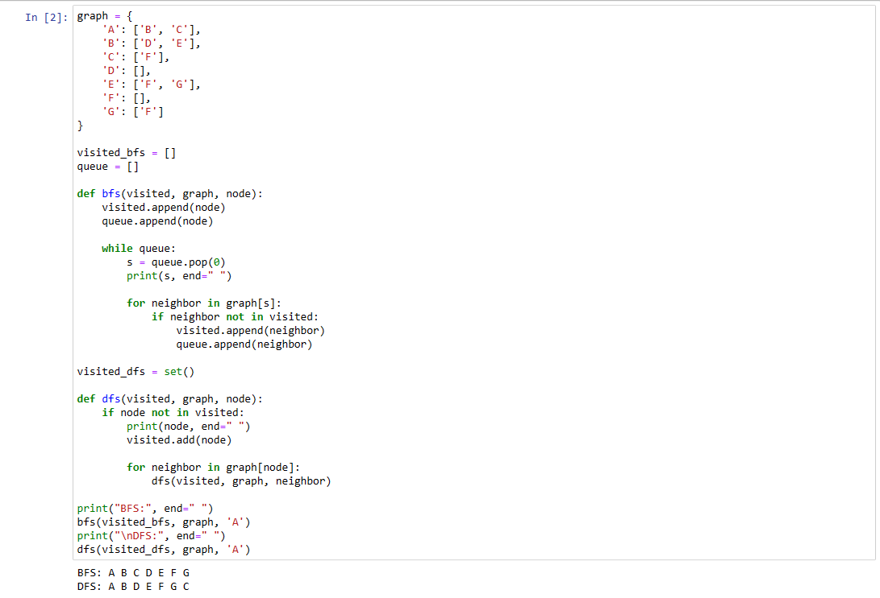

1. **BEST FIRST SEARCH AND A*:**

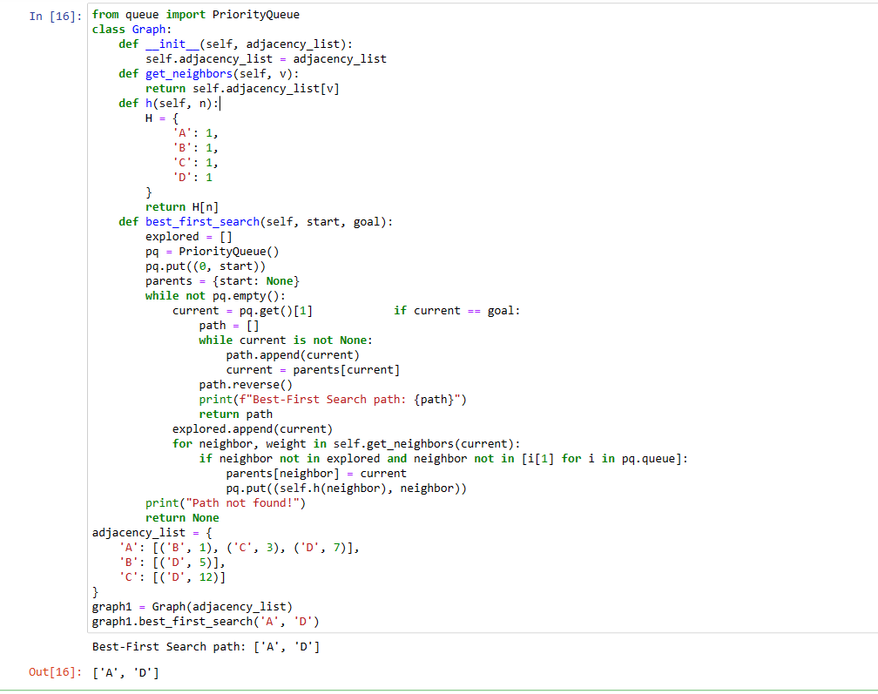

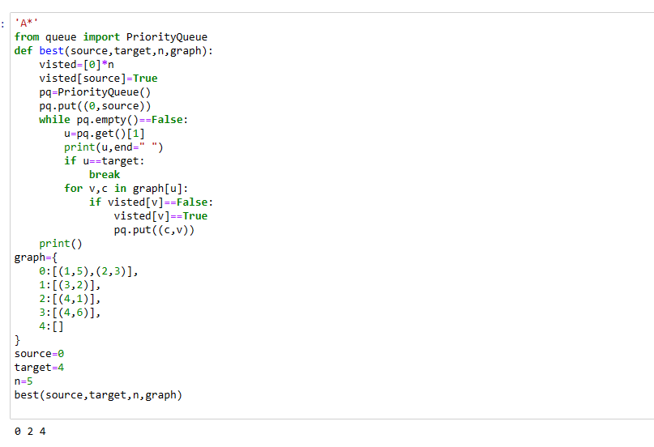

1. **UNCERTAIN METHOD(FUZZY METHOD):**

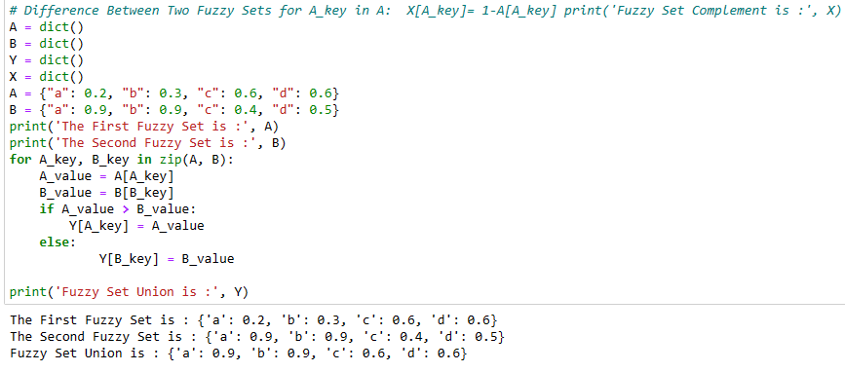

1. **UNCERTAIN METHOD (MONTY HALL):**

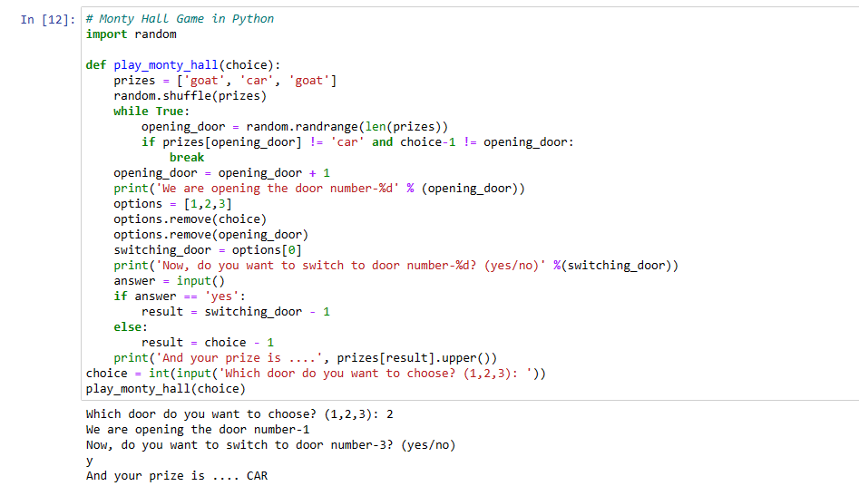

1. **LEARNING ALGORITHM:**
2. **NLP PROGRAM:**